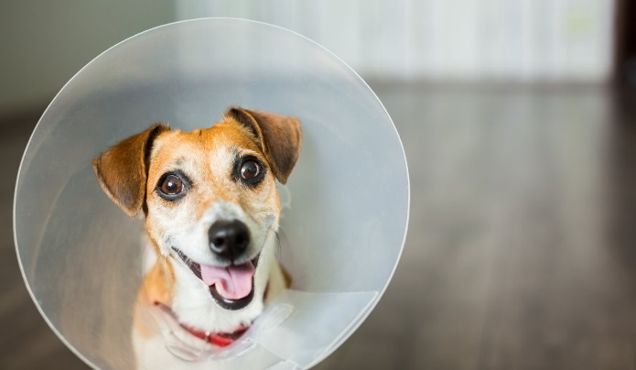

The benefits of Elizabethan collars for pets
We know you hate the E-collar, and we know your pet hates the E-collar, but the truth is, without it, healing will take longer. If your dog or cat has surgery, the shelter might send them home with an E-collar to prevent them from licking or chewing the affected area, which could lead to loose stitches, infection or ingested topical medications. Without it, you stand the chance of re-injury or worse.
3 things NOT to do...

1. (Do not) Feel guilty.
This collar is allowing your pet to heal more quickly, and using it avoids potential emergencies.

2. (Do not) Leave your pet alone for the first several hours.
It’s likely that he’ll need your help at some point. Keep an eye on him and be ready to lend a paw if needed.

3. (Do not) Remove the collar.
Just leave it on. It’ll be over soon, I promise. Some of you may still take it off. And if you must, never leave your pet unattended while it’s off. You will be totally embarrassed when you show up to the emergency clinic with a pet who has damaged his incision. If you must take it off, don’t forget to put it back on.
How to properly fit an Elizabethan collar
When properly fit, an Elizabethan collar should be short enough to allow the dog to eat and drink. At the same time though, you need to make sure that your dog’s E-Collar extends 3 inches past the nose to prevent them from reaching the wound area with their tongue.
How tight should the e-collar be? A good general rule of thumb is it should be tight enough not to slip over their head and come off but not too tight to irritate the skin or rub off the hair. Usually you should be able to fit 1 to 2 fingers between the neck and the collar when the collar is in position.

